**TASK**

Share the **homework_week1_students** file with the groups. They need to recreate the 4 tables exactly as per pictures below. Each table need to be populated with the same data, as we are going to use these tables in the future exercises.

You can find sql script to re-create the DB with tables. It is called **parts_database.sql**

**TABLE – PART**

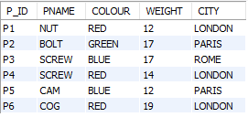

**TABLE – PROJECT**

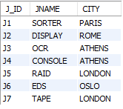

**TABLE -- SUPPLIER**

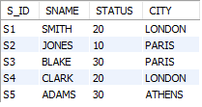

**TABLE – SUPPLY**

